UNIVERSIDAD PRIVADA DOMINGO SAVIO



INTEGRANTES: MILENKA TOREZ ANGULO GUTIEREZ

ALEX PEDRO ALBA

ALEXANDER MOROCHI DE LA RIVA

MATERIA: DISEÑO WEB 2

DOCENTE: FAVIOLA SOLIZ

ACTIVIDAD: PAGINA WEB DISEÑO

CBBA 2022

<https://shaulin199.github.io/Practica2/>

VISTA GRANDE

|  |  |  |
| --- | --- | --- |
| NAV 12 COLUMNAS | | |
| HEADER 10 COLUMNAS | | |
| MAIN 12 COLUMNAS | | |
| IMAJEN 4 COLUMNAS | IMAJEN 4 COLUMNAS | IMAJEN 4 COLUMNAS |
| IMAJEN 4 COLUMNAS |  |  |
| FOOTER 12 COLUMNAS | | |

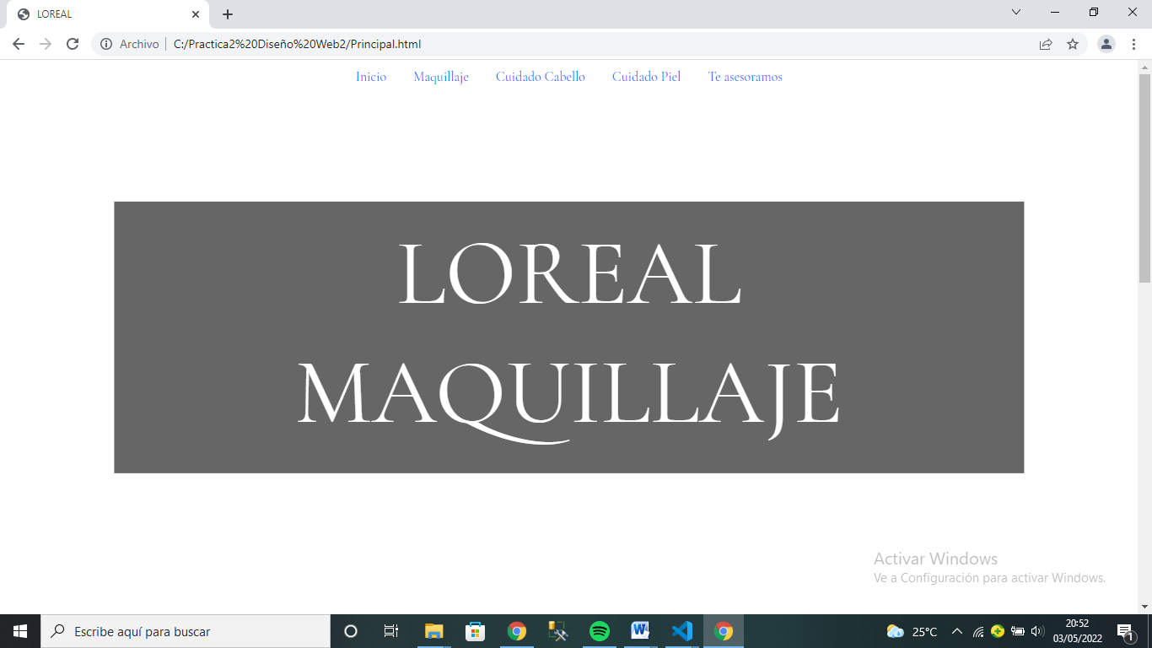

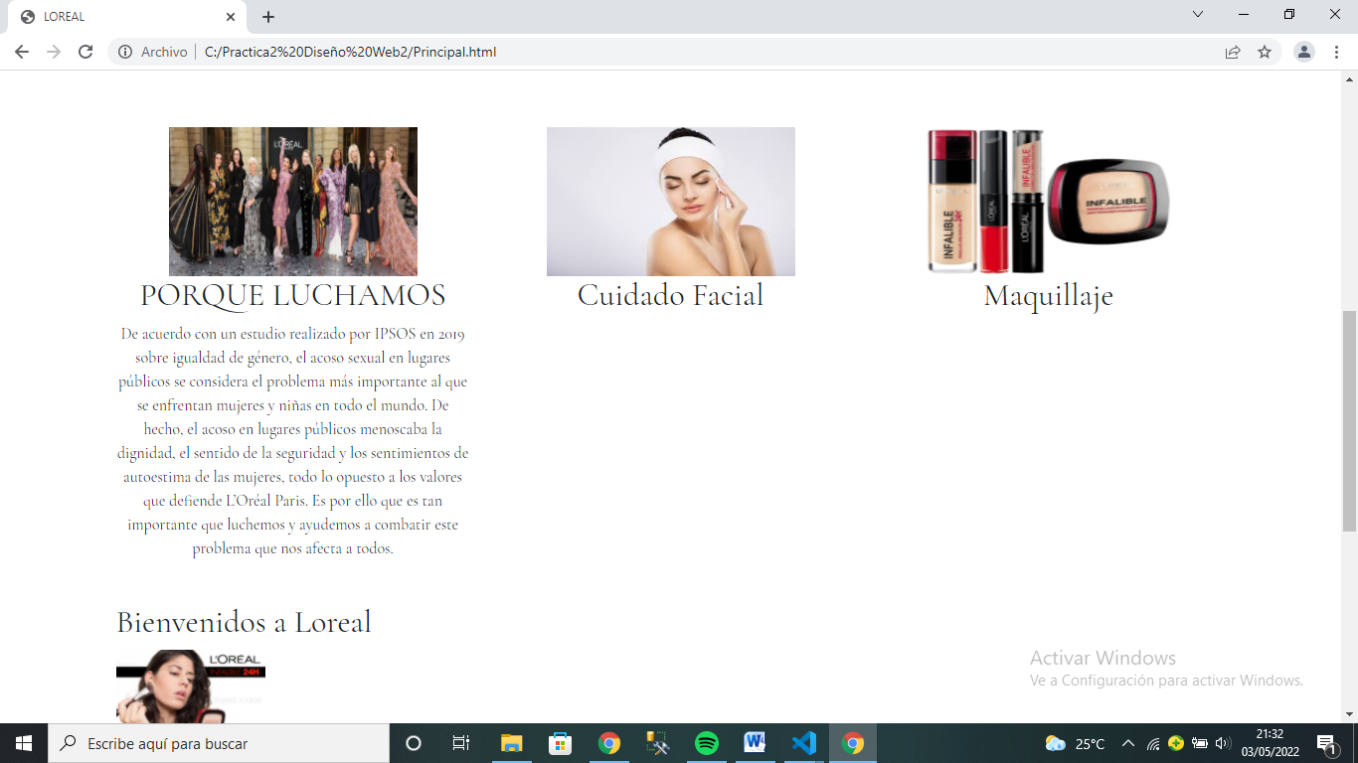

VISTA MEDIANA

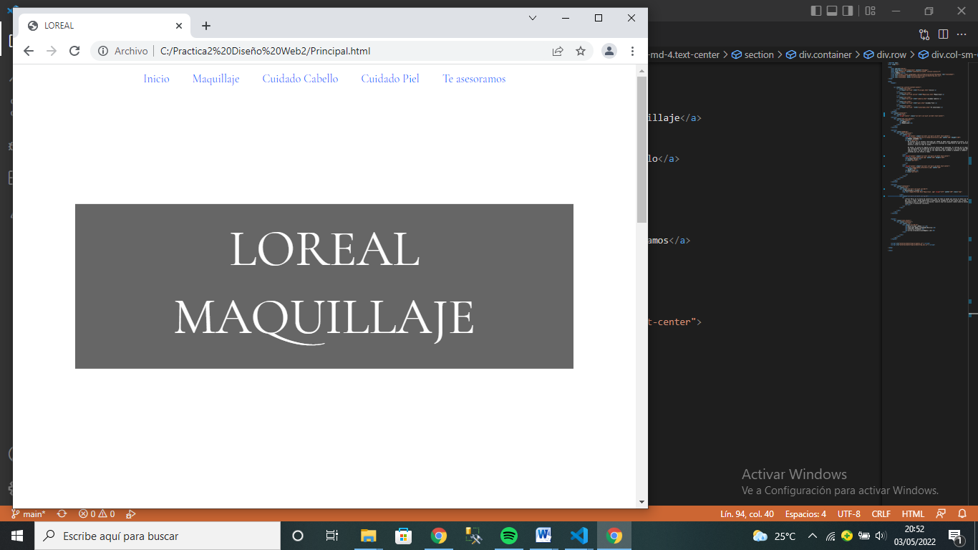

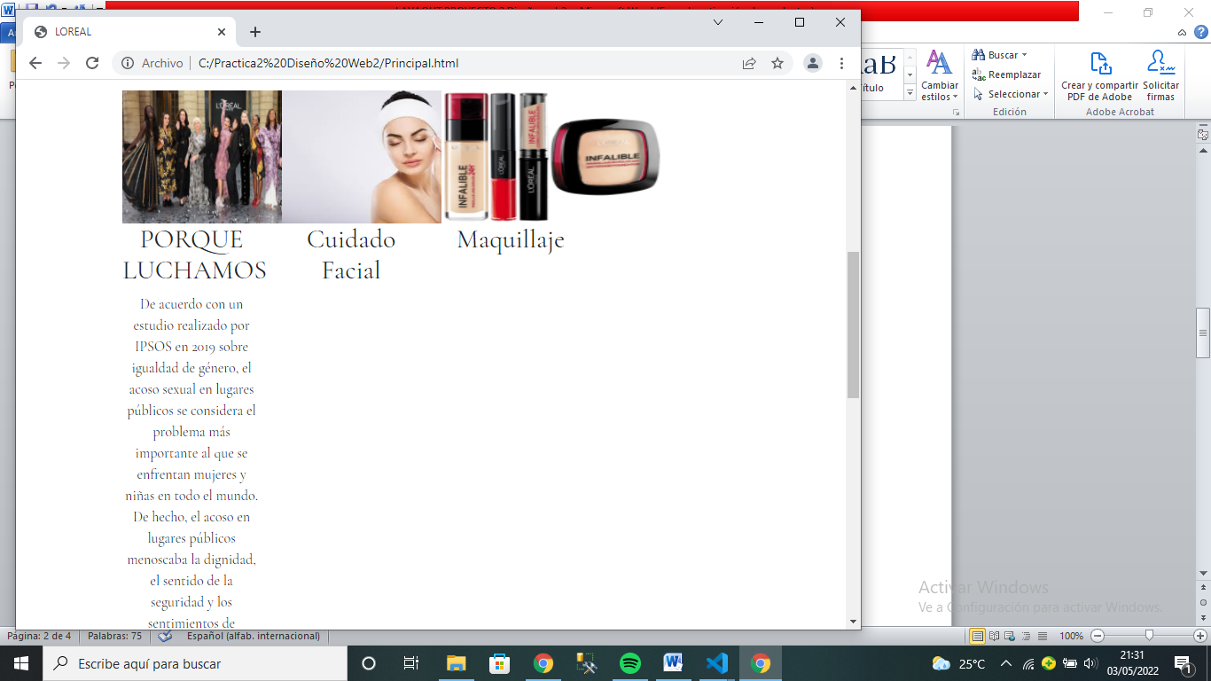

|  |  |  |
| --- | --- | --- |
| NAV 12 COLUMNAS | | |
| HEADER 8 COLUMNAS | | |
| MAIN 12 COLUMNAS | | |
| IMAJEN COLUMNAS 3 | IMAJEN COLUMNAS 3 | IMAJEN COLUMNAS 3 |
| IMAJEN COLUMNAS 3 |  |  |
| FOOTER 12 COLUMNAS | | |

VISTA PEQUEÑA

|  |
| --- |
| NAV 12 COLUMNAS |
| HEADER 6 COLUMNAS |
| MAIN 12 COLUMNAS |
| IMAJEN 12 COLUMNAS |
| IMAJEN 12 COLUMNAS |
| IMAJEN 12 COLUMNAS |
| FOOTER 12 COLUMNAS |

